Database
# Source: AI Source: Provided by: [Data Path: Persons Table -> ID Column: 1, Name_En Column: Motasem Essam] -> From: [ChatGPT] on [6/10/2026]
A database is an organized collection of data that can be easily accessed, managed, and updated.
Think of it like a digital filing cabinet — it stores information in a structured way so you can quickly find, add, or modify data.

🔑 Key Concepts
# Source: AI Source: Provided by: [Data Path: Persons Table -> ID Column: 1, Name_En Column: Motasem Essam] -> From: [ChatGPT] on [6/10/2026]
- Data: The actual information stored (like names, emails, products).
- Tables: Databases usually store data in tables (like a spreadsheet with rows and columns).
- Records: A single row in a table; represents one item or entry.
- Fields: A column in a table; represents a single type of data (like "name" or "age").

Types of Databases
# Source: Table Source: Provided by: [Data Path: Persons Table -> ID Column: 1, Name_En Column: Motasem Essam] From: [Data Path: Miscellaneous Folder -> Miscellaneous Database -> Miscellaneous Table -> ID: 44] on [6/10/2026]
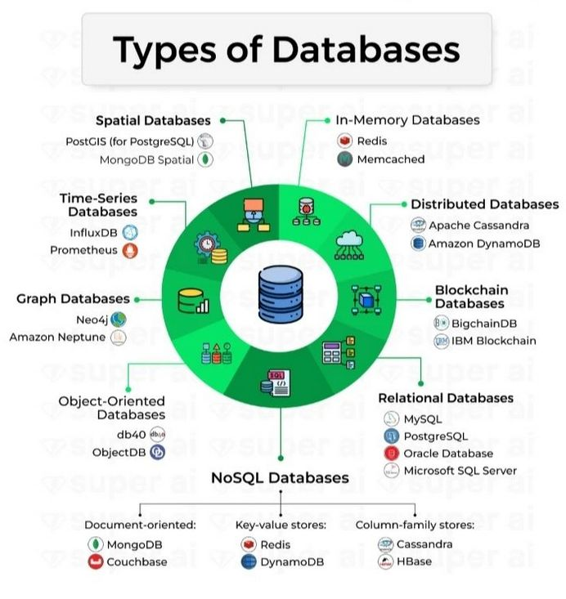

🧱 Relational Databases and Non-Relational Databases
# Source: AI Source: Provided by: [Data Path: Persons Table -> ID Column: 1, Name_En Column: Motasem Essam] -> From: [ChatGPT] on [6/10/2026]
- Relational Databases (SQL)
  - Data stored in tables with relationships.
  - Use Structured Query Language (SQL) to manage data.
  - Examples: MySQL, PostgreSQL, SQLite, Microsoft SQL Server
- Non-Relational Databases (NoSQL)
  - More flexible structure (e.g., documents, key-value pairs).
  - Used for big data, real-time apps, etc.
  - Examples: MongoDB, Redis, Firebase, Cassandra

📦 Example: A Table in a Relational Database
# Source: AI Source: Provided by: [Data Path: Persons Table -> ID Column: 1, Name_En Column: Motasem Essam] -> From: [ChatGPT] on [6/10/2026]
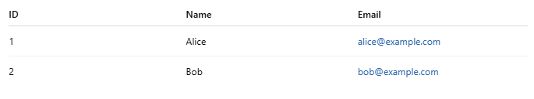
ID | Name | Email
1 | Alice | alice@example.com
2 | Bob | bob@example.com
Each row is a record, and each column is a field.

💡 Common Uses
# Source: AI Source: Provided by: [Data Path: Persons Table -> ID Column: 1, Name_En Column: Motasem Essam] -> From: [ChatGPT] on [6/10/2026]
- Websites storing user accounts
- E-commerce storing product details
- Apps storing messages, posts, or transactions
- Analytics storing logs and reports

Let me know if you'd like a beginner code example using SQL or how to connect a database to a website.

what is schema of the database
# Source: AI Source: Provided by: [Data Path: Persons Table -> ID Column: 1, Name_En Column: Motasem Essam] -> From: [ChatGPT] on [6/10/2026]
The schema of a database refers to the structure or blueprint that defines how data is organized within the database. It describes:

🔧 Key Components of a Database Schema:
# Source: AI Source: Provided by: [Data Path: Persons Table -> ID Column: 1, Name_En Column: Motasem Essam] -> From: [ChatGPT] on [6/10/2026]
- Tables: Core structures where data is stored (e.g., Users, Orders, Products).
- Fields (Columns): Attributes of the data in each table (e.g., user_id, name, email).
- Data Types: Specifies the type of data allowed in each column (e.g., INTEGER, VARCHAR, DATE).
- Keys:
  - Primary Key: Uniquely identifies each record in a table.
  - Foreign Key: Links records across tables.
- Constraints: Rules for data integrity (e.g., NOT NULL, UNIQUE, CHECK).
- Relationships: Defines how tables are related (e.g., one-to-many, many-to-many).

📘 Example (SQL-style schema)
# Source: AI Source: Provided by: [Data Path: Persons Table -> ID Column: 1, Name_En Column: Motasem Essam] -> From: [ChatGPT] on [6/10/2026]
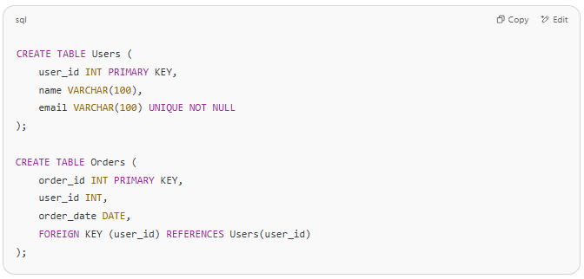
CREATE TABLE Users (
user_id INT PRIMARY KEY,
name VARCHAR(100),
email VARCHAR(100) UNIQUE NOT NULL
);

CREATE TABLE Orders (
order_id INT PRIMARY KEY,
user_id INT,
order_date DATE,
FOREIGN KEY (user_id) REFERENCES Users(user_id)
);

This defines a schema with two tables: Users and Orders, and a one-to-many relationship (one user can have many orders).

